Career Activity Curriculum Topic: Scholarship Tracking

Career Activity: Research and Track Scholarships
Estimated Time: 55 minutes
Learning Plan Activity: 11th Grade: Scholarship Tracking; 12th Grade: Financial aid and Scholarship Tracking
Activity Summary: This lesson will help students explore how to research scholarships most effectively.

Learning Outcomes: Students will demonstrate knowledge of where to find scholarships, when and how to do so in order to earn as many as possible.

Materials Needed: PowerPoint, Handout, Pen, Computer, Scholarship Tracking Form*
*(Digital Copy or paper)

Academic Vocabulary:
- Scholarships: Free money awarded to students who apply and meet certain requirements based on criteria determined by various individual entities.
- Weighted GPA: Weighted GPAs take the difficulty of a class into account. More challenging courses, like honors or AP classes, can be worth more than a 4.0 – up to a 5.0, actually – depending on a student’s grade.
- Unweighted GPA: An unweighted GPA relies on a 4.0 scale and, on that scale, no grade is worth more than a 4.0, regardless of the type of class involved.

Introduction: [Use PowerPoint] One of the challenges you’re probably facing right now is figuring out how to pay for college. In addition to grants and loans, you may also be eligible for scholarships to help pay for your expenses. Today we are going to explore different types of scholarships, who should apply, what you need, when to start, and where to find scholarships. Before we get started, take a few minutes on the Scholarship Knowledge Inventory Handout to identify some things you may already know! We will fill this in today together as we gain more understanding.

Scholarships aren’t just for your school’s star athletes or people with really high grades. Awards can be need-based, meaning that they require students to demonstrate that they need financial assistance beyond what their family is able to contribute. There are also scholarships you may qualify for based on an affiliation you or your parents have, like from a religious organization you belong to, or from a nonprofit you volunteer for. Finally, you might find organizations that are interested in helping students of a particular ethnicity or other intrinsic characteristic.

Learning Activities/Procedures: Give each student a copy of the Handout_Scholarship Knowledge Inventory. Have them complete it as a pre/post or as you go along with the presentation.

Types of Scholarships: Play video: What is a Scholarship? - Quick and Easy Explanation (~ 3 minutes)
Class Discussion:
- Who has started to look for scholarships?
- Do you plan on applying for scholarships? –Why or Why Not?
- By your senior year and within the senior year you may change your mind on college and trade schools – Apply anyway as lots could happen and you may get a lot of money!
- Idaho has students who have received full rides numerous times –Ex. Full ride to Brown University, quarter of a million dollars, school paid for flights home, clothing, food, board, tuition, books, etc.
  - This is an extreme, but there is money out there to be received if you put your name in the pot.

Who should apply?
What do you need to apply?
When to start looking?
- How many of you have started to look?
- Get Smart! Start Early, Prepare Ahead of Time, and Get More Scholarships!
- Research heavily during the Junior year especially in the spring and through the summer
Where do you find scholarships?
- High School Website (not just your own high school, look at others)
- Google “Scholarships” and see what you find
  - Do not ever provide personal information (especially your Soc. Sec. Number)
Tracking your Search:
- Why would it be important to track your research or scholarships?
  - Save time later
  - Could forget info or not remember how to find scholarships you found
  - Can better organize when you will start working on the various ones found
- How might you do so?
  - Paper format
  - Document on Your Computer
  - Look online for examples and on your school website
- How many scholarships can you apply for?
  - Apply for as many as you qualify for, as this will increase the likelihood of you receiving money
  - You are allowed to get as many as awarded

Organizing your Search: Have each student open the digital handout_Next Steps Scholarship Application Tracker Fillable or have them create their own digitally or on paper. Use this tool or create your own to keep track of the scholarships that you find and want to apply for.

Scholarship Activity: Use any of the websites listed below to locate 3 scholarships and include the following information for each: Scholarship Name, Award Amount, Eligibility Requirements, Award Deadline, URL for application.

Have students use computers in pairs or individually and use the websites:
- www.nextsteps.Idaho.com [ https://nextsteps.dev.s360.is/scholarships/ ]
- www.bigfuture.collegeboard.org

Encourage students to write down/organize the information they find so they can apply before the deadlines!
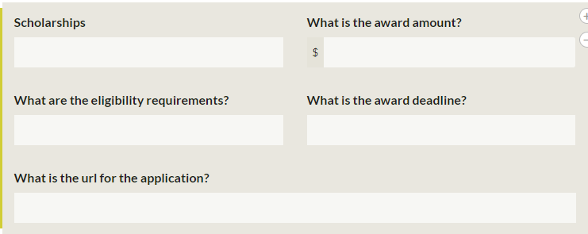

Questions:
- When is the best time to start looking for scholarships?
- Where should you look for scholarships?
- Who can you ask about scholarships?
- Can I get more than one kind of scholarship?
- What kinds of scholarships exist?

Adaptations:
- Assign students to research 3 scholarships they will apply for. This does not just have to be for college scholarships but could be for trade schools as well. Have them use the scholarship search tracking form example or make up their own way to track scholarships details and information. This one is best used with those who use it electronically.
- Students could turn it in electronically to you by email (if using the document provided with this activity) or create one of their own, or you could provide a format you would rather they use by paper. There are various ones online.
- If possible, some teachers could also have students turn in proof they have researched 5 scholarships a month (or that they have actually applied to 5 a month) and get credit for it for the class.
  - Providing credit works, as it usually gets kids more motivated to do them. They need the push.
  - Another idea is to have seniors work on this activity during advisory time.

Evaluation: Students will be able to complete the ‘Scholarship Tracking’ Learning Plan Activity.

Closing: Now that you have explored locating scholarships, what ways do you think would be easiest to track or organize what you need to apply and when it needs to be submitted? Remember that all of you can apply and find scholarships that will help you go on!

Scholarships Knowledge Inventory Handout Answer Key:
- A, B
- A
- A, B, C, D
- D
- Answers will vary
- Answers will vary
- Answers will vary
- A, B, D
- B

