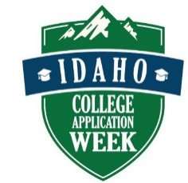
Idaho College Application Week
Pre-Event Information Survey
Return by October 11, 2017

Site Name: _________________________________________________
Site Coordinator: ____________________________________________
Site Coordinator - Email Address: _______________________________
Site Coordinator Phone:_______________________________________
Number of seniors: __________________________________________
Remember, - events must be held during the school day on a day when school is in session. You must have a method of working with cohorts of students so that all seniors have the opportunity to complete applications.
In the space below, please describe your current plans for reaching all seniors with your primary Idaho College Application Week event.

Idaho College Application Week: November 6, 2017 – November 10, 2017
During this week, which day(s) will you host events?
€ Monday Time: ___________________________
€ Tuesday Time: ____________________________
€ Wednesday Time: _________________________
€ Thursday Time: ___________________________
€ Friday Time: ______________________________
€ We are a virtual school and request: ______________________________

Please return via email to dana.kelly@osbe.idaho.gov or mail it to
Idaho College Application Week
Office of the State Board of Education
P.O. Box 83720
Boise, ID 83720-0037
Phone: 208-332-1574

